Uploading an Artifact/Class Assignment to LiveText
This tutorial will walk you through the process of uploading a class assignment to LiveText. First you must log into LiveText using your LiveText credentials. If you do not currently have a LiveText account or have forgotten your LiveText login information, please contact the LiveText coordinator Dar. Barb Rowland at rowlaba@quincy.edu.
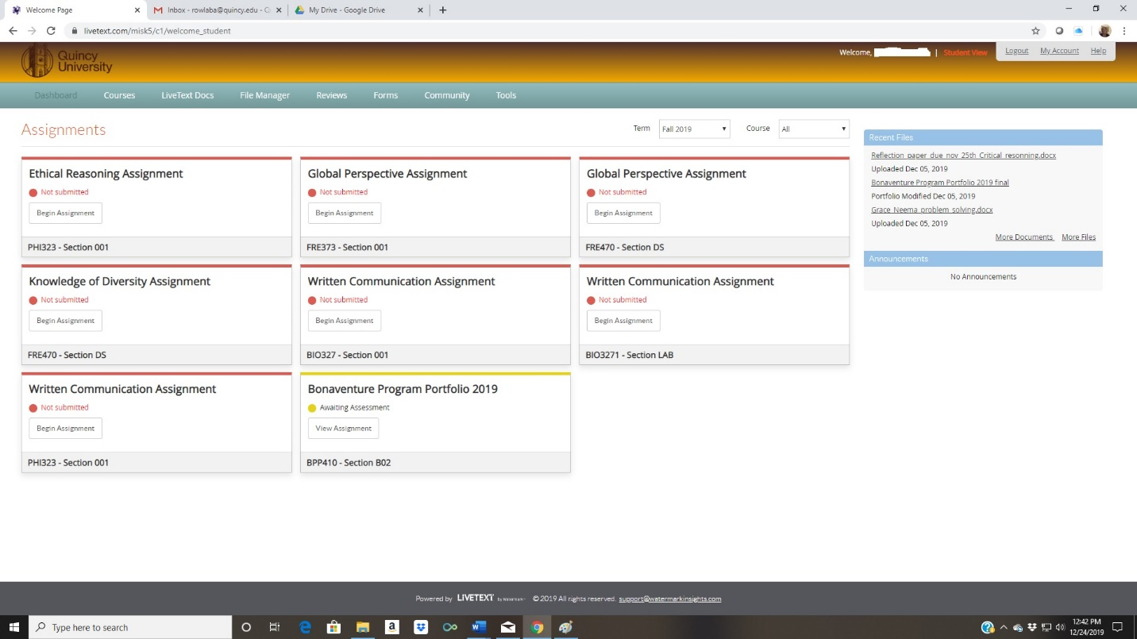
Within LiveText you will see your student dashboard. The dashboard will list all your current (and past) classes that utilize LiveText. The Dashboard will show the LiveText Assignment and the name of the class. For example, on this student dashboard, we can see the student has several Global Perspective Assignments within LiveText. One Global Perspective Assignment is for FRE373 and another is for FRE470. Similarly, there are two LiveText Assignments for Written Communication. You will need to locate the exact class and assignment instructed by your professor. In this example, we will be uploading a Written Communication Assignment to BIO327. So, we will click on the link that says BEGIN ASSIGNMENT.
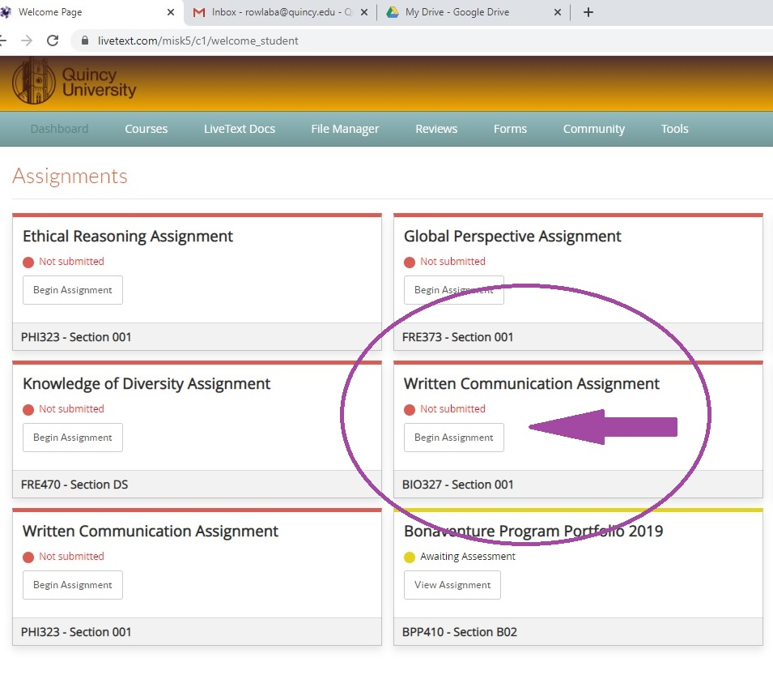
You will now be taken to the screen that will allow you to upload your assignment. Your professor has instructed you exactly which assignment from the class you will need to upload into LiveText.
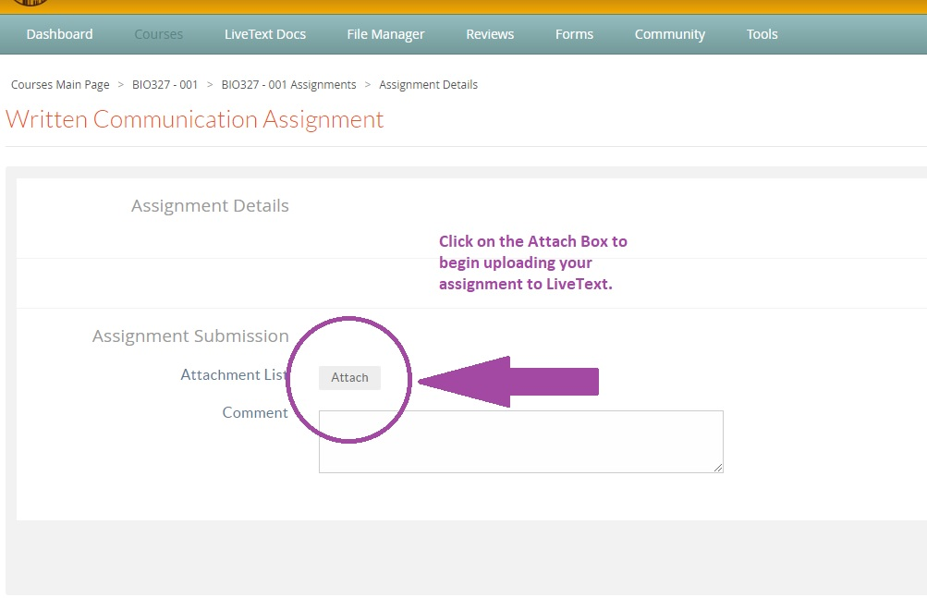

Now you will be taken to the dialogue box where you can access your exact assignment to upload. Click on the UPLOAD link on the far right. This will now allow you to select the exact file you wish to upload.

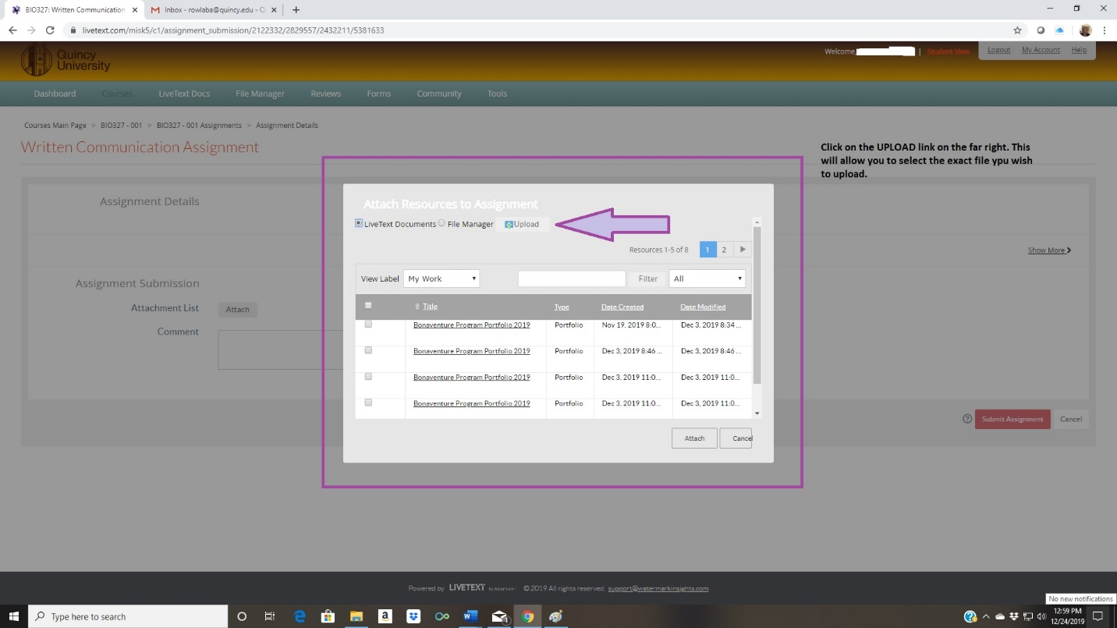
You can now access your files for uploading.
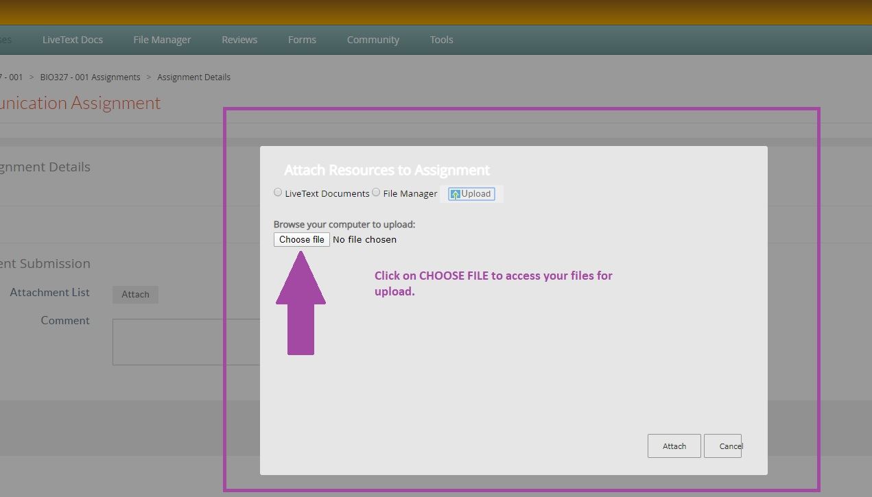

From here, the process is much like attaching any document to an email or to Moodle. You search for the location and the file you wish to upload to the LiveText Assignment.
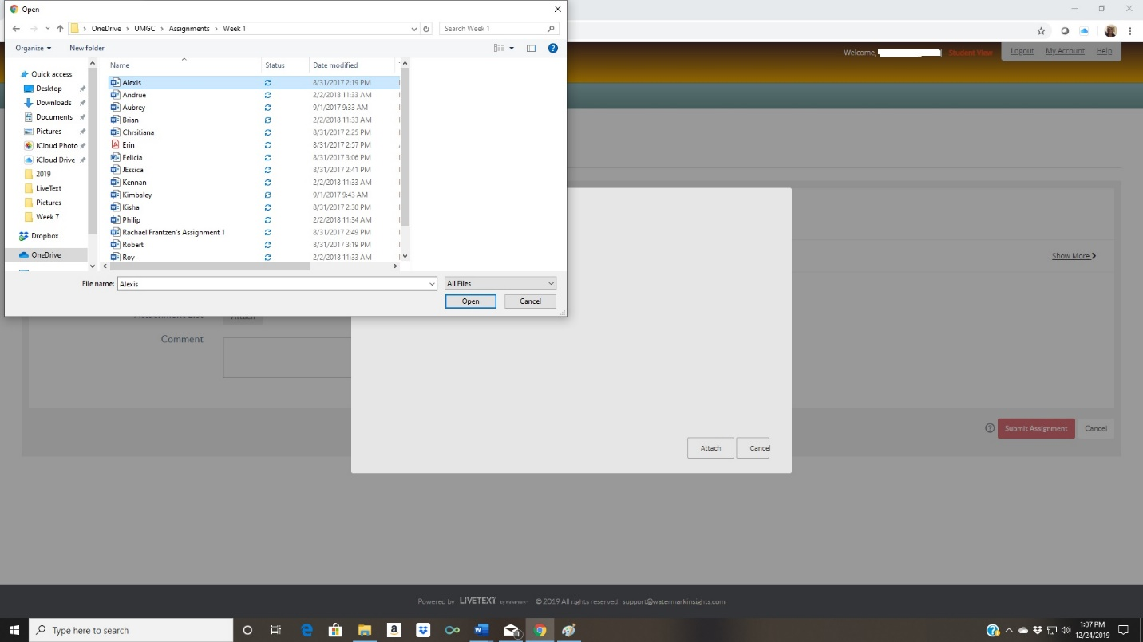
Make sure you can see the exact file you wish to upload and then click on the ATTACH link in the lower right-hand corner.
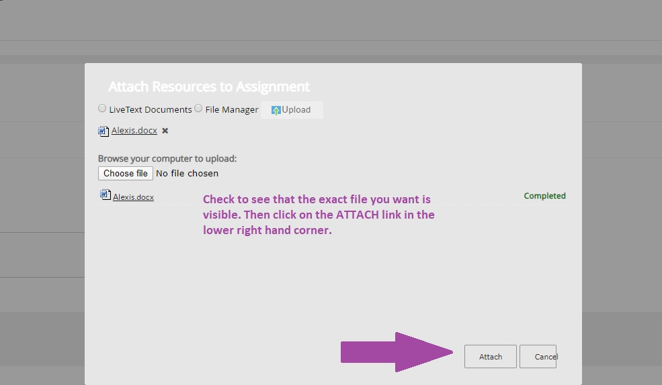
Check once more to make sure the exact file you want is visible. Then click on SUBMIT ASSIGNMENT.
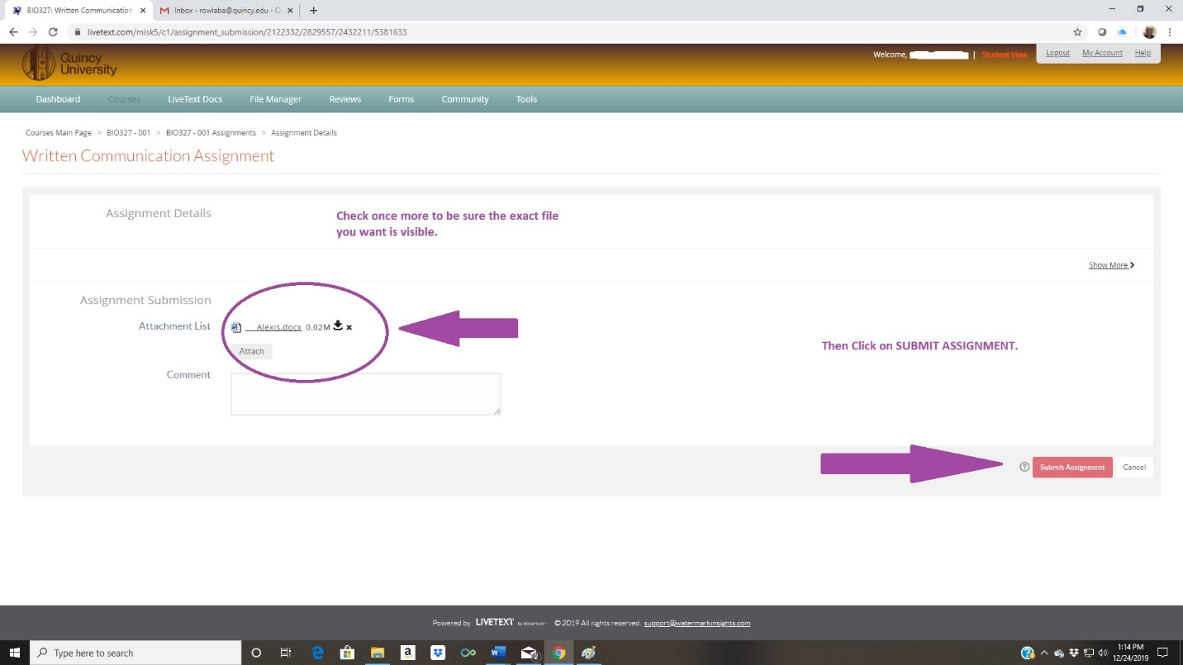
You should receive a confirmation screen:
