Adding the Instructions to a LiveText Assignment
Once a competency rubric has been uploaded into your live text class, you will be able to see that rubric listed as an “assignment” in your class. In the example below the competency rubric is for “Written Communication.” When I log in to my Live Text class, I can see “Written Communication” listed as an assignment:
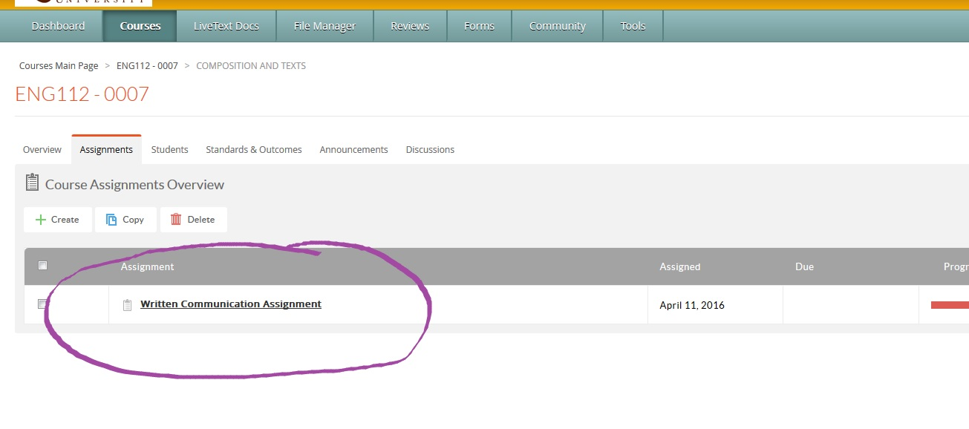
This is where students will upload the class assignment you give them. For example, I want my students to upload their final writing assignment from our English 112 class. I feel the final essay will best reflect the criteria in this Written Communication Value Rubric.
It is important to also add the instructions for the assignment within LiveText. Your students will likely already know the requirements for the assignment; however, Academic Assessment Committee members who are assessing the Bonaventure Program Learning Outcomes within LiveText, will not know the requirements of the assignment. Having the guidelines for the assignment helps us to more effectively assess the assignment in relation to the value rubric.
To add the instructions for your LiveText assignment, you must first access your LiveText course. Then click on the ASSIGNMENTS tab at the top.

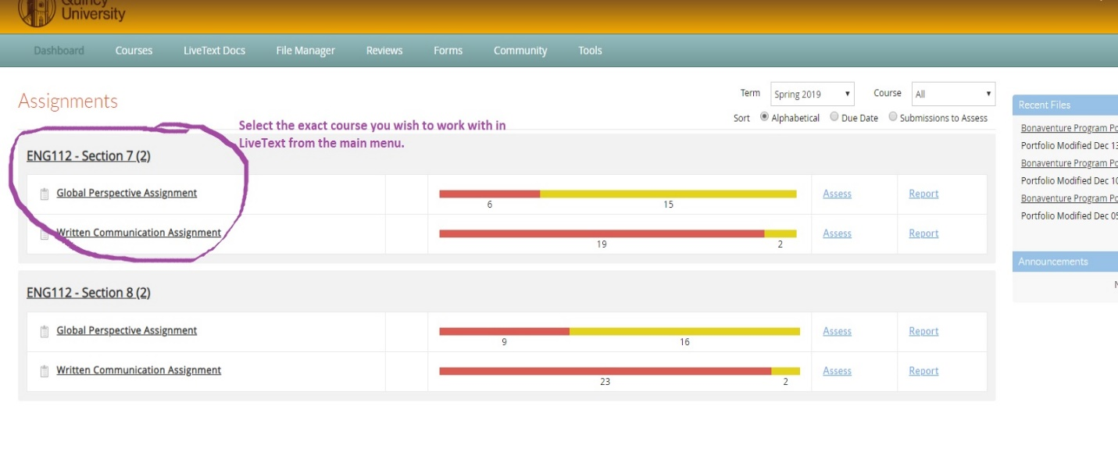

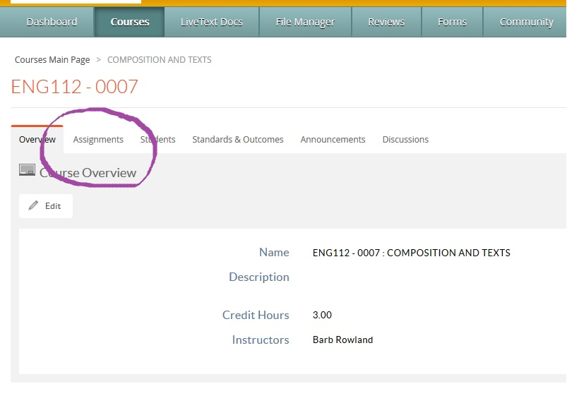
You will be able to see all assignments in this Live Text course. IT is possible you may have more than one value rubric uploaded to your course. In this example. I have the Global Perspective Value Rubric and the Written Communication Value Rubric. Click on the assignment you wish to work with.
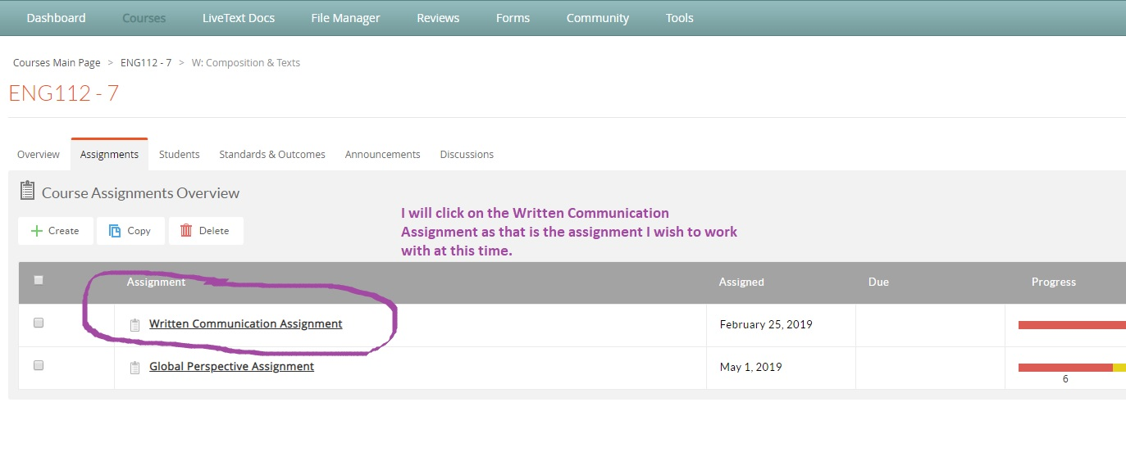
This will bring me to a screen that will allow me to edit my assignment. Click on the EDIT tab at the top.
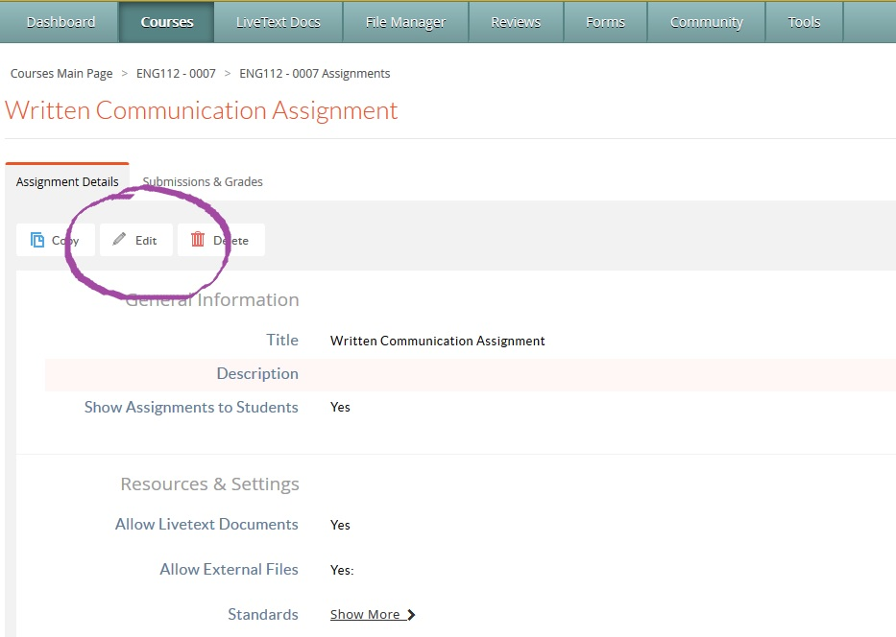
Now I can include a description of the assignment (or instructions) for my students and for those assessing the assignment.
