Assessing Student Work in LiveText
Once students have submitted their work to the LiveText Course Assignment, instructors will need to assess that work. The goal is to select 5 random representative samples of student work. (You do not need to assess ALL submissions for QU assessment requirements-only 5). You will need to click on the Live Text Course Assignment and then click on the SUBMISSONS AND GRADES tab at the top.
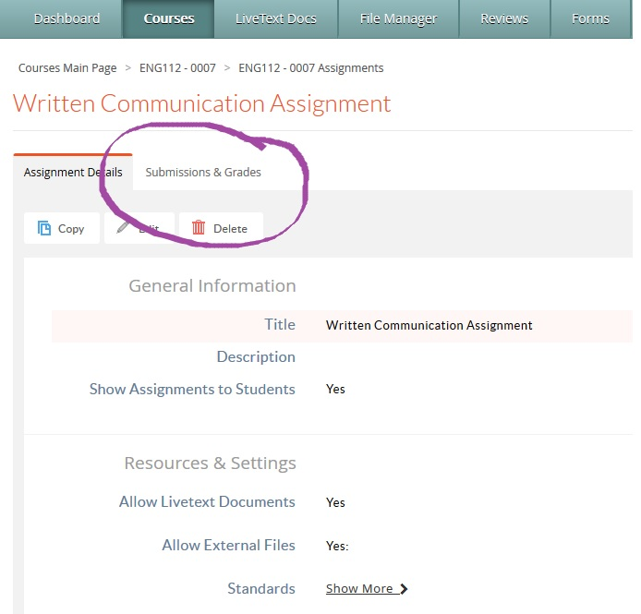

You will now see a list of the students who have already submitted their work for this assignment, along with a list of students who still need to submit. We want 100% submission. Continue to coach students who have not submitted to upload their work.
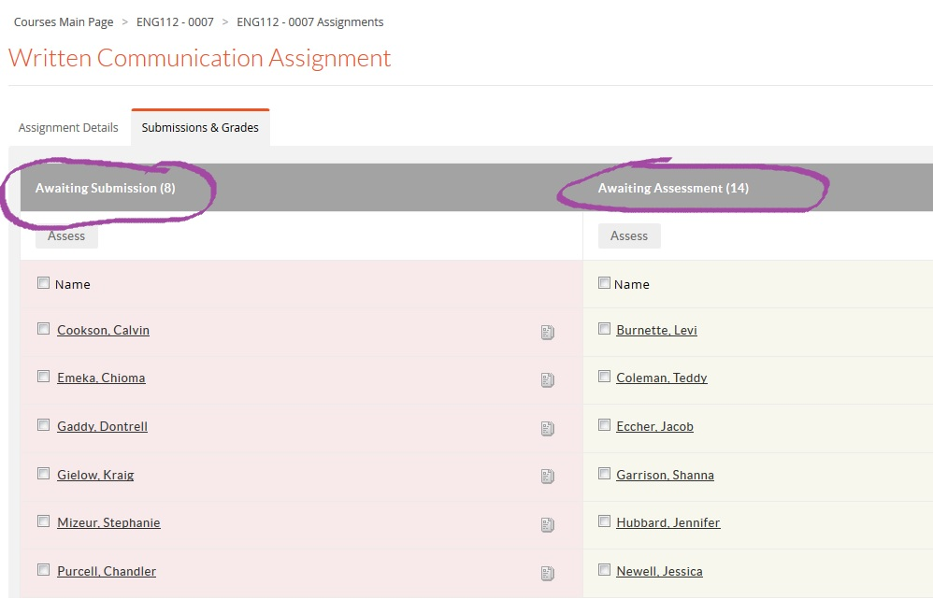

When you are ready to assess the student work, check one of the five students you wish to assess for QU’s assessment requirements. Then, click on the ASSESS tab located below the “Awaiting Submission” column.
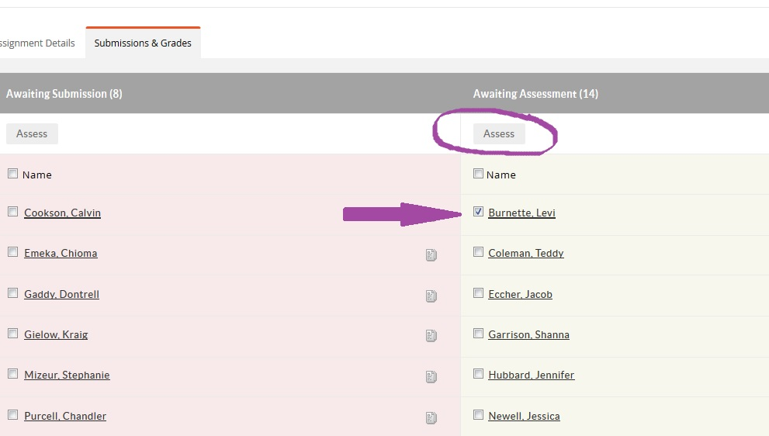
You will now see the QU Assignment Rubric that has been uploaded into your course. You should see the name of the student being assessed, the document attachment (assignment) to be assessed, and the rubric. You will want to click on EXPAND RUBRIC to see the full rubric criteria.
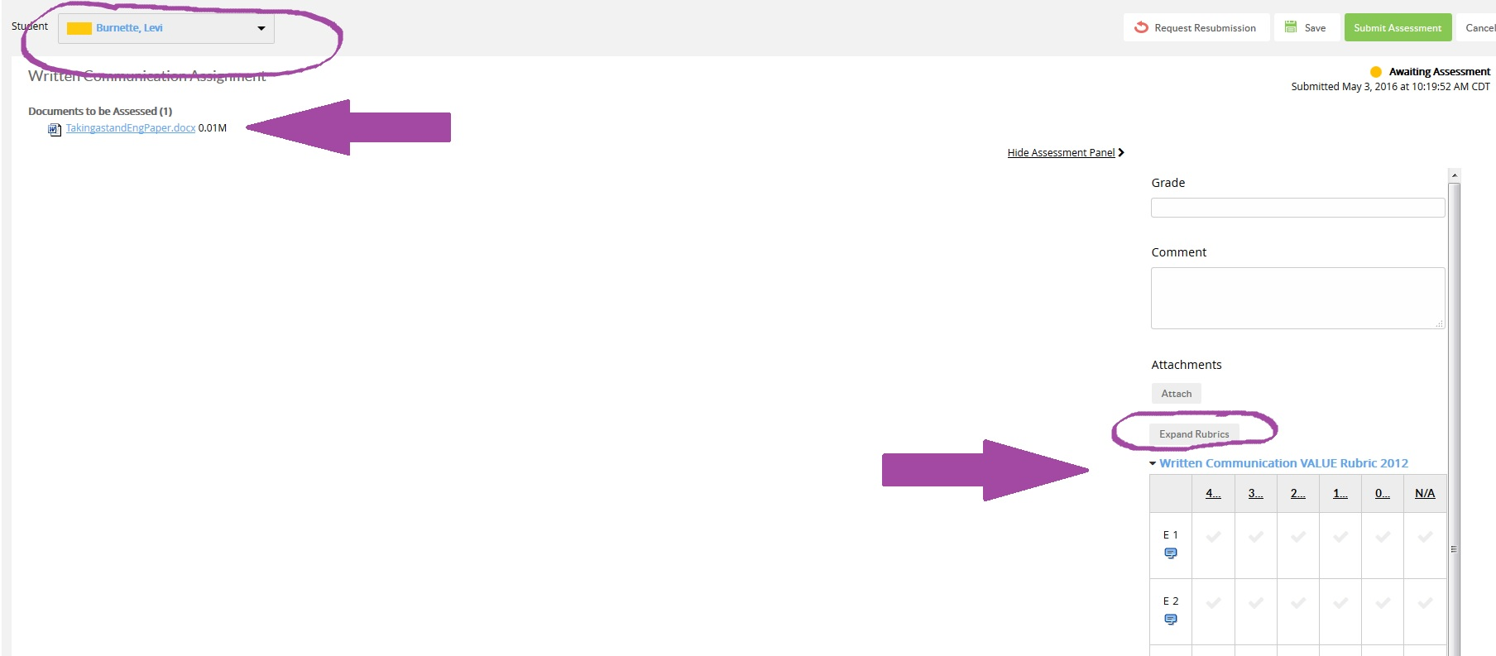

Once you Expand the Rubric, it will appear in a new window. You are now able to assess the student work based on the criteria in the rubric. Remember, this assessment may be different than the assessment you complete and record in Moodle. The QU Competency Rubrics assess general learning competencies students are acquiring in their courses. You may look for other criteria when assessing the assignment. As you work through the rubric, check the level of student earning as either (4) Capstone, (3) Milestone, (2) Milestone, (1)Benchmark, or (0)Does Not Meet. Be sure to SAVE.

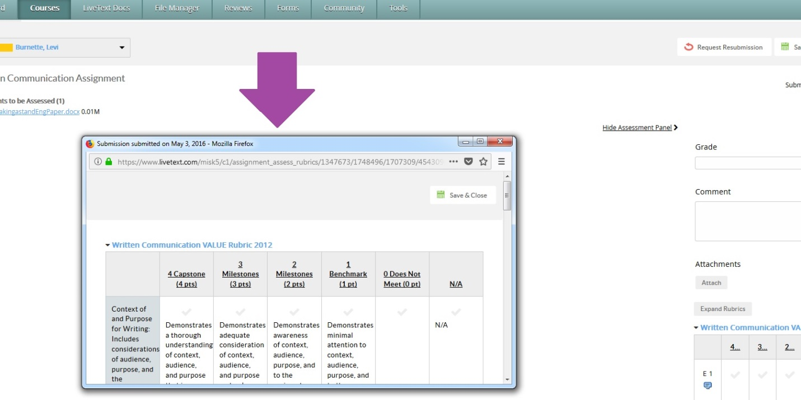
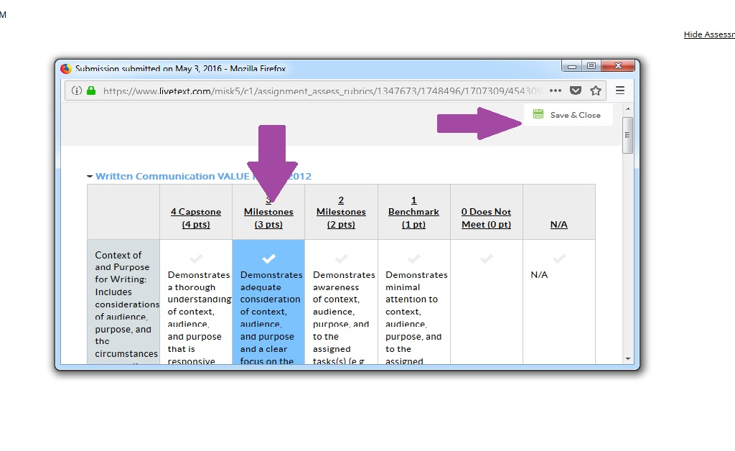
You are able to offer comments about the assessment if you wish. Then, click Submit Assessment.
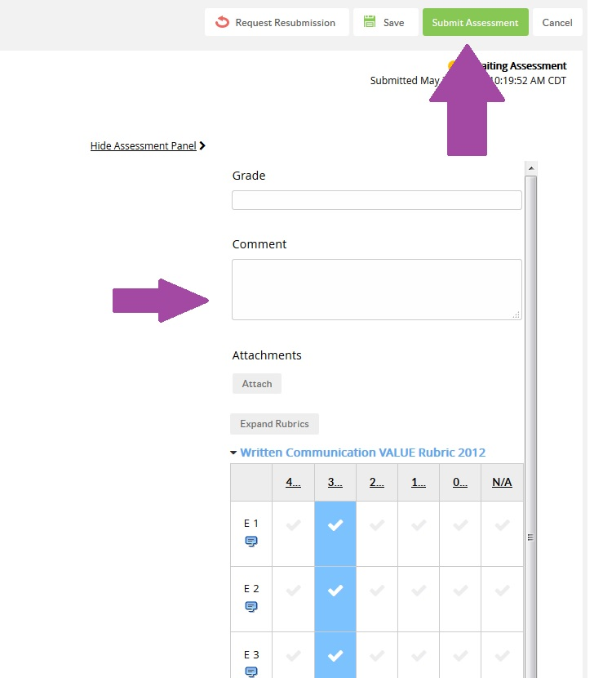

The student assignment is now listed as “Completed.”
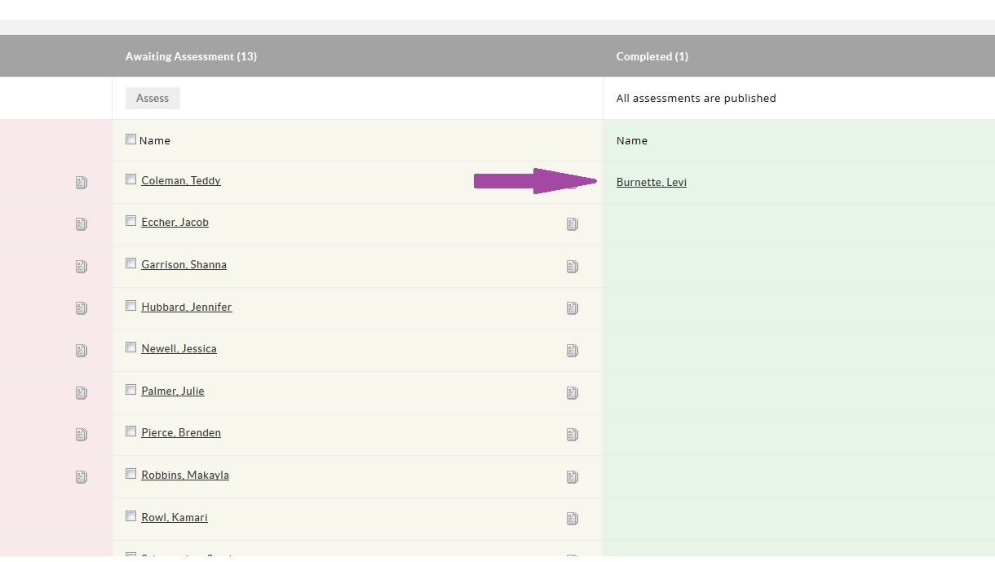

If you get an Error Message indicating that you must “Set Visibility” you must set the “Assessor Visibility” to “You” in order to assess/submit.
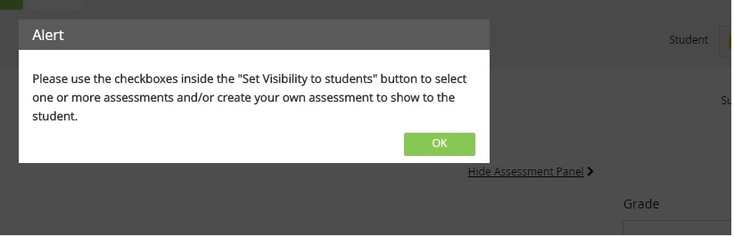
You can do so by clicking on the “Assessor Visibility” button, select the radio button next to “You”, and then click “Set Visible”.
